**Our Services**

**Travel and Stay**

Beach Resorts:

**BEACH RESORTS**

Who hasn’t dreamt about stepping out of your room onto the sand? Here in Goa, we make that dream a reality with Goa’s exclusive range of beach resorts.

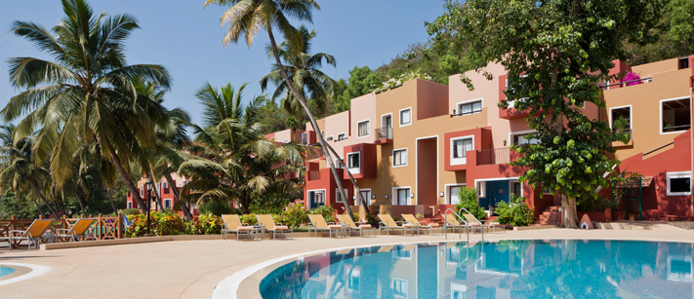

**CIDADE DE GOA**

Cidade De Goa is an ultra-luxurious resort spread across an area of 40 acres of lush green landscape. The resort has been gifted with a breath taking view of baingunim beach and is an ideal 5 star property for corporate events. The resort is one of the most iconic In Goa with its distinct Portuguese and Iberian architecture.

**Baywatch Resort**

Baywatch Resort is nestled in the serene coastline of Sernabatim Beach in colva , this contemporary and luxurious resorts offers elegant and spacious rooms and Suits equipped with amenities to make you have a memorable holiday in Goa.

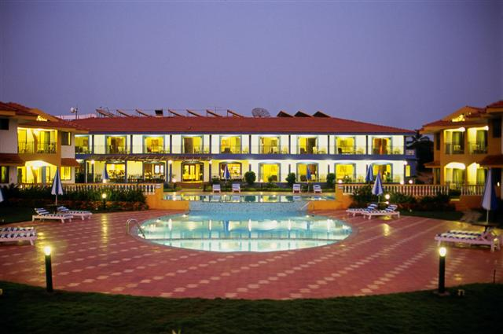

**Ramada Caravela Beach Resort**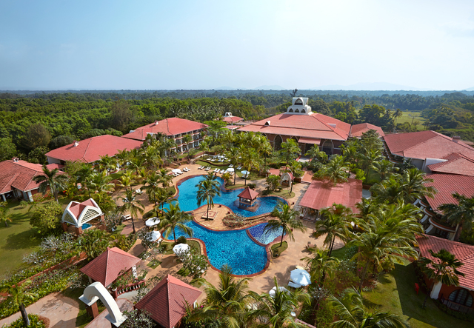

Located on the serene sands of Varca Beach, Ramada Caravela Beach Resort is a 5-star property, spread over 24 acres and has 199 rooms. Each of the guest rooms, suites and villas has a private balcony that overlooks either the ocean or landscaped gardens or one of Goa's largest pool. A 9 hole golf course, a Casino and an Ayurveda Centre, differentiates this from any other five star in Goa.

**Zuri White Sands**

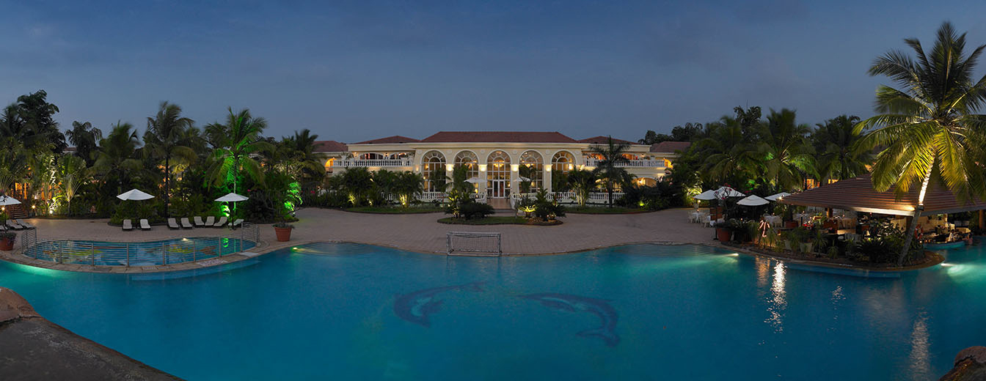

The Zuri White Sands in Goa sits on a picturesque white-sand beach, Varca. The resort boasts of a spectacular view of the sea from their Goan styled luxury rooms. The restaurant offers authentic Goan, European and Pan Asian cuisine that is sure to tickle your taste buds and a state of the art casino in its premises.

**Holiday Inn Resort**

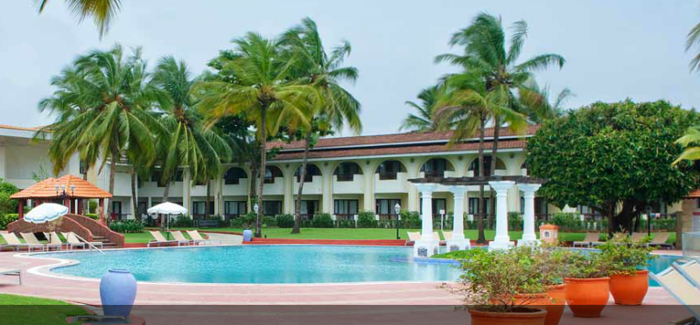

Holiday Inn Resort is located at Mobor beach, Cavelossim, Goa. This five star beach resort has a huge property with a captivating style that combines traditional Goan architecture with contemporary design and luxurious finishing. You can choose spacious accommodation in a stunning beachfront setting with the option of a garden view, pool view or sea view.

Villa Resorts

Aguada Anchorage

Aguada Anchorage offers a world-class resort with the comfort and privacy of a private villa. The Villas within resorts offer a utopian combination for many travelers with spacious and well-appointed accommodations featuring all of the amenities that a world-class resort has to offer. This unique resort is styled on the lines of a Goan hamlet, sprawling over 8 acres of lush greenery and seamlessly blending into the environment.

Joie de Vivre Goa Boutique Villa

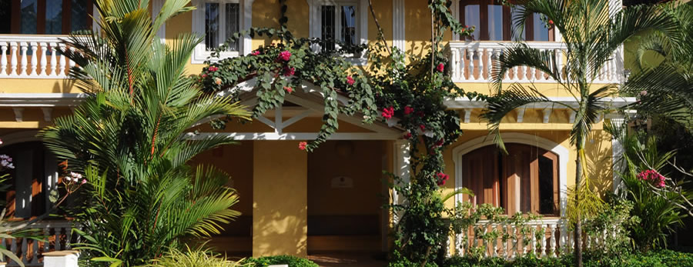

Joie De Vivre is a boutique villa resort that rests in the rustic village of Nagoa, offering one a recluse from city living amidst tranquil environment. The resort offers 3-5 bedroom villas and apartments for recreational living fully equipped with major lifestyle amenities.

Casadegoa

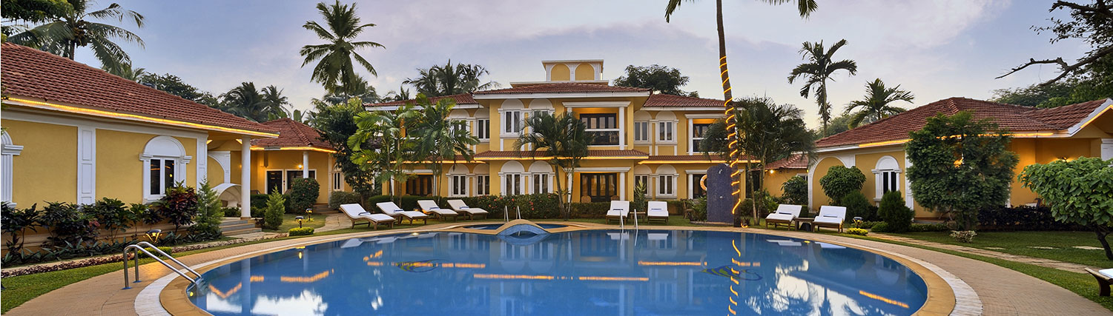

Casa de Goa offers a large double bedroom villas and apartments with luxurious features like espresso machines and bathtubs located right across its crystal clear swimming pool. Experience the comfort and luxury on offer while enjoying homely and personalized service.

**Wildflower Villas**

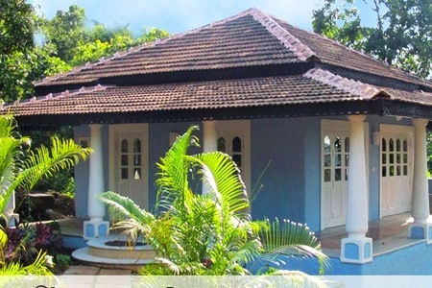

Wildflower Villas is a boutique villa resort in Goa on an 8 acre hilly property overlooking the Sinquerim River and the Aguada Bay . The villas offer for lush green and a fresh environment which promises simplicity, peace, privacy and a personalized service.

**Business Hotels**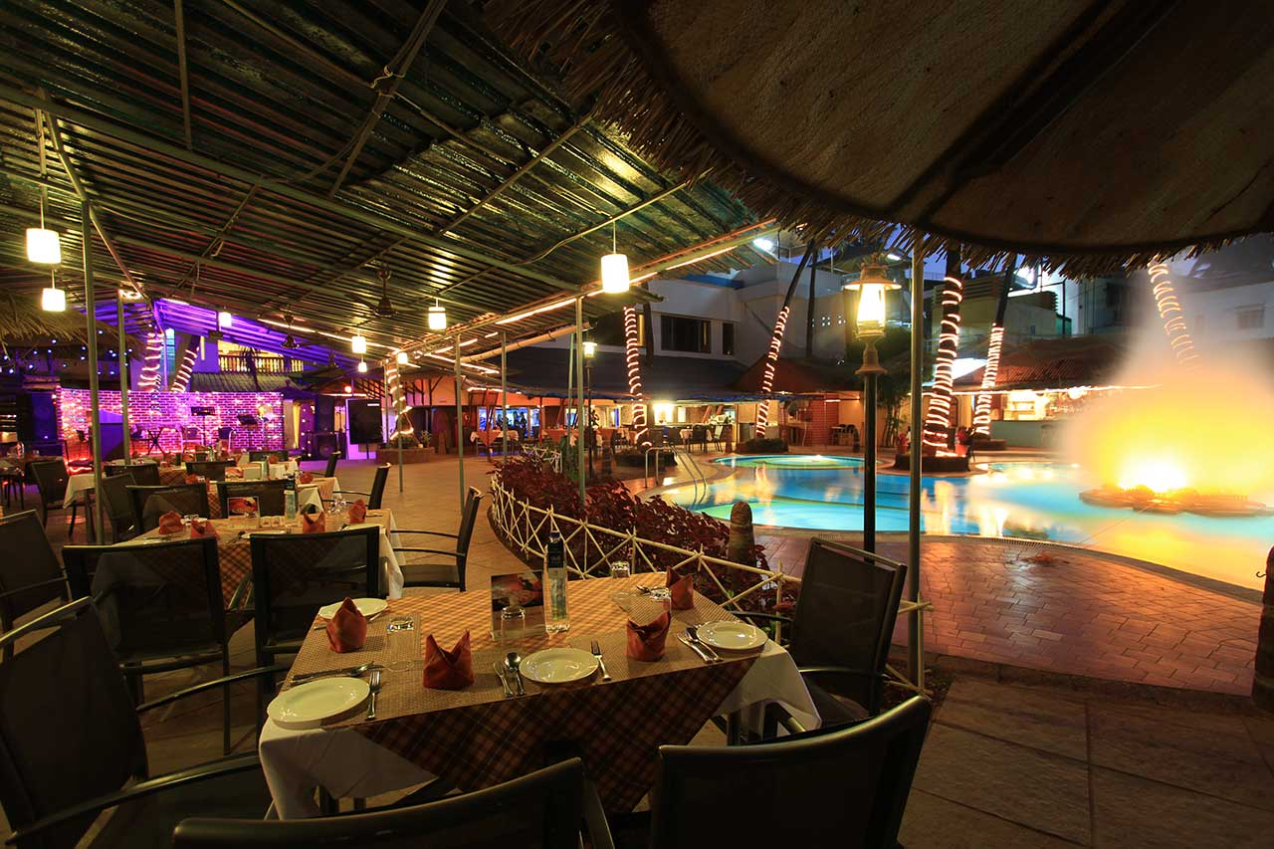

**Hotel Fidalgo**

Hotel Fidalgo offers a luxury retreat in the heart of one of Goa’s Capital City, Panaji. The hotel features over 100 lavishly designed rooms and suites and has multiple restaurants within the complex.

Salida Del Sol

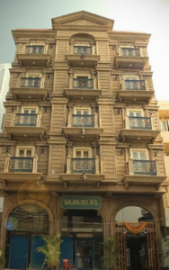

Salida de Sol is a unique boutique hotel catering especially to business travelers. Conveniently located in the beautiful city of Panaji, its aim is to merge style & substance seamlessly through this space and offer its guests a complete urban experience.

**The Mandovi**

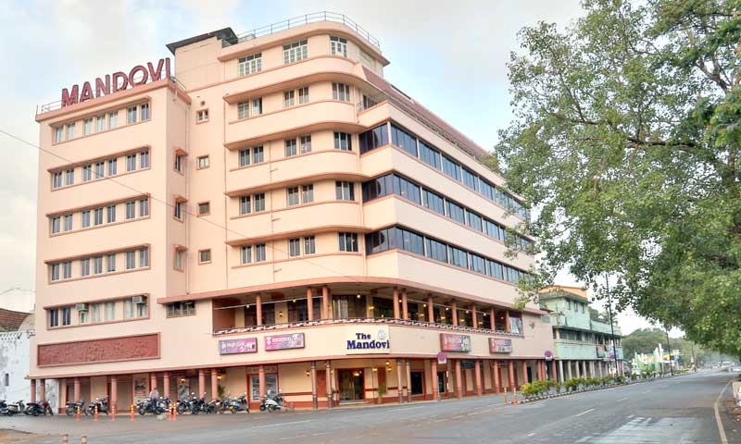

Perched on the banks of the river Mandovi, this hotel is one of the oldest in the City. The Mandovi has created a legacy of its own in the world of hospitality and guests can be assured comfort and elegance during their stay here. The hotel also has an authentic Goan restaurant, besides other common amenities.

**Vivanta by Taj**

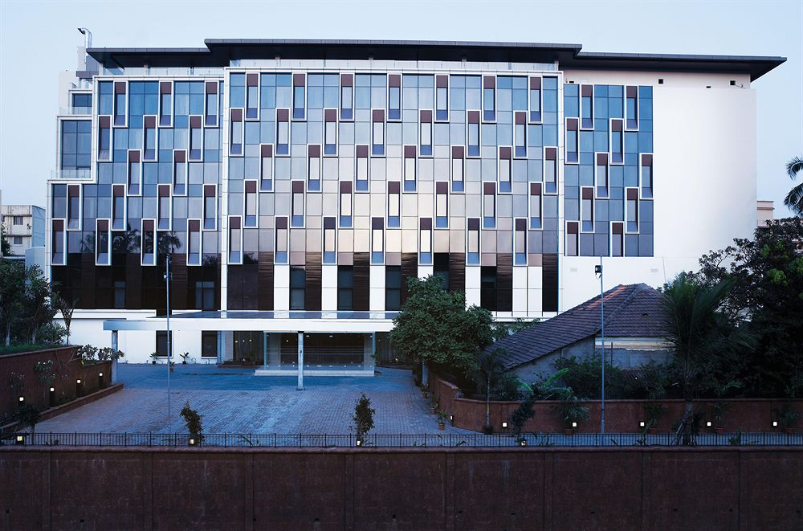

Panaji’s trendiest and most luxurious boutique hotel, Vivanta is ideal for business travelers. This stunning 5 floored establishment comprises of 170 rooms and facilities like 24 hour help desk & reception, internet access, banquet facility, and a range of restaurants.

|  |
| --- |
| **The Crown**  http://exp.cdn-hotels.com/hotels/2000000/1790000/1782800/1782707/1782707_12_b.jpg  Located on a hillock, The Crown is perfect for both – corporate as well as leisure travellers. Each room is well-furnished. These rooms offer a home-away-from-home experience to its patrons. From comfortable beds with spotless linen to a flat screen television, clothes rack and a work-desk. It comprises various features like internet access facility, travel and help desk and a beautiful pool side restaurant with a full view of Panaji. |
|  |
|  |
| **Ginger Hotel**  **http://www.travelland.in/Goa_tour/Gimg/Ginger1.jpg**  The Ginger Hotel is located in the Corporate hub of the City. Comprising of 135 comfortable and well equipped rooms, the hotel offers a joy of features including Self Check-In kiosk, Net Zone, conference rooms, a gymnasium and much more. |

**Incentive TRAVEL**

Planning an incentive package for your well deserving employees? Goa has a plethora of unique options to choose from.

**STAY options**

Aguada Anchorage

Aguada Anchorage offers a world-class resort with the comfort and privacy of a private villa. The Villas within resorts offer a utopian combination for many travelers with spacious and well-appointed accommodations featuring all of the amenities that a world-class resort has to offer. This unique resort is styled on the lines of a Goan hamlet, sprawling over 8 acres of lush greenery and seamlessly blending into the environment.

Joie de Vivre Goa Boutique Villa



Joie De Vivre is a boutique villa resort that rests in the rustic village of Nagoa, offering one a recluse from city living amidst tranquil environment. The resort offers 3-5 bedroom villas and apartments for recreational living fully equipped with major lifestyle amenities.

**CIDADE DE GOA**

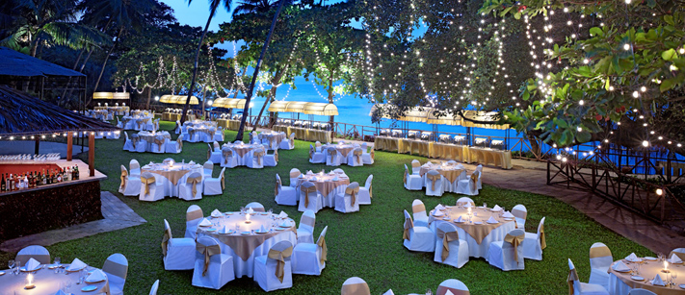

Cidade De Goa is an ultra-luxurious resort spread across an area of 40 acres of lush green landscape. The resort has been gifted with a breath taking view of baingunim beach and is an ideal 5 star property for corporate events. The resort is one of the most iconic In Goa with its distinct Portuguese and Iberian architecture.

### [**Quinta da Graça**](http://www.jdoqocy.com/click-3368958-10775740?URL=http%3A%2F%2Fwww.tripadvisor.com%2FHotel_Review-g3136739-d2407128-Reviews-a_cja.10775740-a_cjp.3368958-m13092-s1-Quinta_da_Graca-Saligao_Bardez_Goa.html)

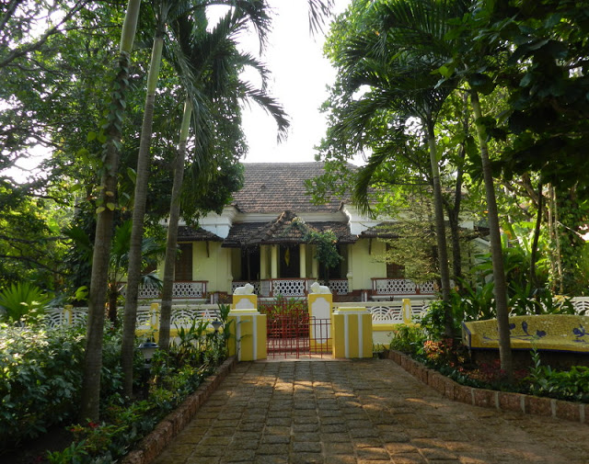

Quinta da Graça is a charming Indo-Portuguese colonial mansion, dating back to the 1940s. Expect rooms with high ceilings, antique Belgian crystal chandeliers, period furniture, and a serene walled garden surrounding the house. Guests are accommodated in four bedrooms, plus a two bedroom cottage.

### [**Olaulim Backyards**](http://goindia.about.com/od/goa/ss/Stunning-and-Serene-Olaulim-Backyards-Homestay-in-Goa.htm)

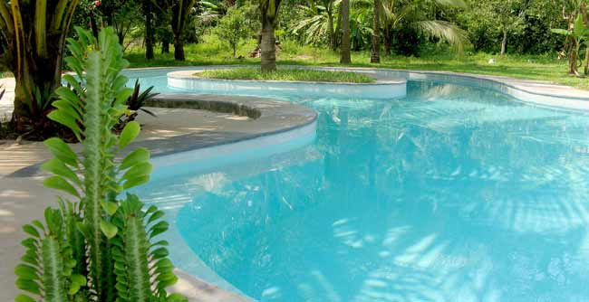

Olaulim Backyards is a homestay with three delightful eco-friendly cottages, where you can really get back to nature. It’s perfect for those who like an active vacation enjoying the great outdoors. There's a swimming pool, kayaking, village walks, bird watching, a tree house, and menagerie of pets.

**DOUBLE TREE BY HILTON**

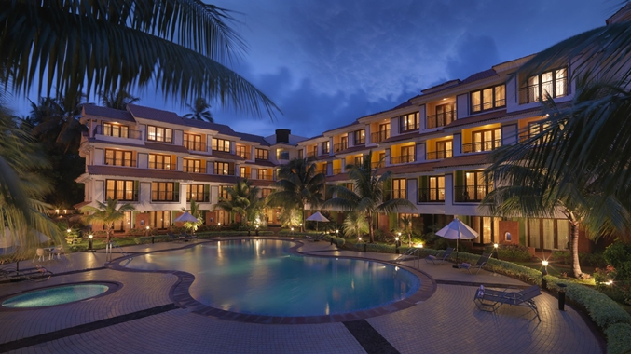

Double Tree by Hilton Hotel Goa is located next to the popular Baga beach, ideally situated in the scenic countryside of Arpora. Relax in a comfortable, casual setting or meet with friends and family and unwind with your favorite drink. Choose to dine at one of their welcoming restaurants. Refresh with a swim in their sparkling outdoor pool or simply relax on the spacious sun terrace.

**The Tamarind Hotel**

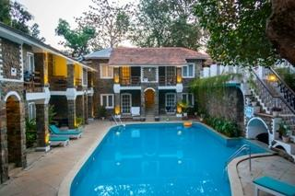

The Tamarind hotel is a luxury boutique hotel situated in Anjuna, its uber luxury and close proximity to nearby beaches and famous shacks makes it a value proposition for vacationers looking for some laid back luxury. It’s designed to give guests a sense of exclusivity and privacy, you are never too far from the Hotel’s pool and Restaurant and the staff is just a whisper away.

**Ocean Bliss Resort**

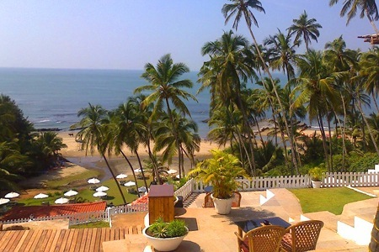

# Set amidst the virgin sands of Ozran Beach in Vagator, Ocean Bliss is an exclusive and private beach resort. Perfect for couples with its spectacular view of vagator Beach, the resort has 14 fully equipped exclusive beach side cottages. One can dine by the poolside bar and choose among a wide variety of cuisines.

**Events**

Goa has a plethora of five starred resorts with luxurious and well equipped conference halls for the perfect event. Here are some of the numerous options Goa has to offer.

**Hotels**

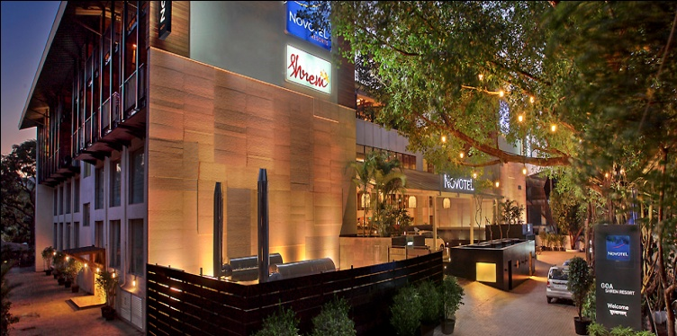**NOVOTEL**

Featuring an outdoor pool and a spa and health club, Novotel Goa Shrem Resort is conveniently located on Candolim Road, just over a quarter mile from the gorgeous Candolim Beach. Rooms offer varied categories & features from contemporary to family accommodating rooms & duplex suites. The resort comprises of enticing food & beverage options and a large banquet hall that is ideal for diverse events.

**CIDADE DE GOA**



Cidade De Goa is an ultra-luxurious resort spread across an area of 40 acres of lush green landscape. The resort has been gifted with a breath taking view of baingunim beach and is an ideal 5 star property for corporate events. The resort is one of the most iconic In Goa with its distinct Portuguese and Iberian architecture.

**GRAND MERCURE GOA SHREM RESORT**

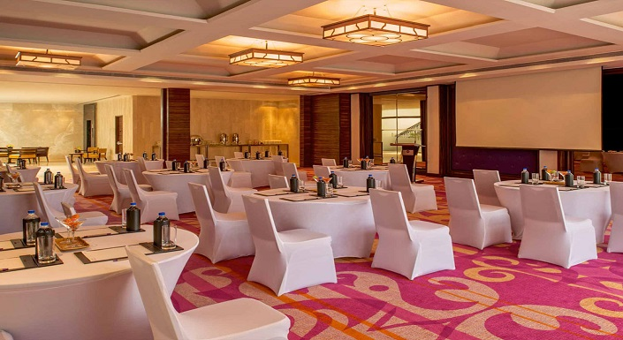

A breathtaking resort by Accor, just off North Goa's bustling nightlife and beaches, this is a perfect place for both families and business travelers seeking relaxation. With unique features like a Vitality Pool, an extensive Spa with 10 treatment rooms offering various therapies from Ayurveda to Hammam, Family apartments, Restaurants, Bar, Meeting rooms, Fitness center and kids play area, etc.

**Alila Diwa Goa**

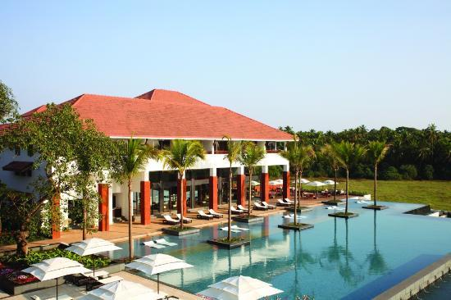

Alila Diwa Goa brings a refreshingly unique resort experience to Gonsua Beach in Majorda, just 20 minutes from Goa Dabolim International Airport. Set amidst the serene landscape of lush, verdant rice plantations flowing towards the Arabian Sea, relaxation reigns at this Goa resort. Enter a sanctuary of contemporary elegance inspired by traditional Goan design − steeply pitched roofs, ceiling high columns, cool verandas and tranquil courtyards, setting us apart from other luxury hotels in Goa.

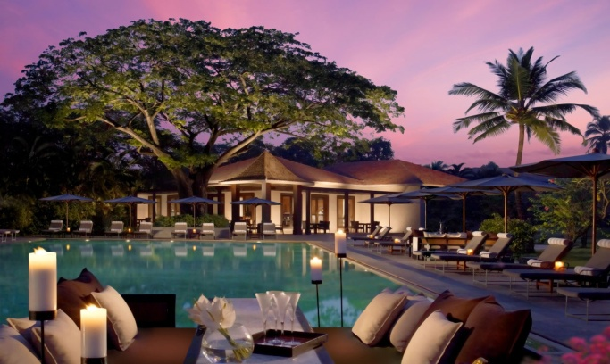**The Leela Goa**

The Leela Goa is one of those breath taking 5 star resorts that leave you in awe .The hotel is set in 75 lush acres with a pristine beach, a 12 hole golf course and world class dining making it the finest 5 star hotels in Goa.

**THE CROWN**

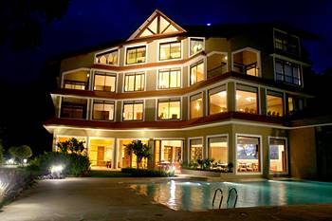

The Crown Goa is a Goan Boutique Hotel situated in the capital city of Goa in Panjim. Unlike most of Goa’s 5-star hotels that bank on their sea view to attract customers, the Crown is perched on the top of a hillock in the center of Panjim and offers a breathtaking view of the city and the Mandovi River flowing along it.

**Why Goa?**

**Why Goa?**

Goa definitely has the best of hotels in its portfolio, from a mix of tranquil nature resorts to its plethora of five star luxury establishments, Goa has it all, why look anywhere else when you can have the time of your life in paradise?

**HOTELS:**



**CIDADE DE GOA**

Cidade De Goa is an ultra-luxurious resort spread across an area of 40 acres of lush green landscape. The resort has been gifted with a breath taking view of baingunim beach and is an ideal 5 star property for corporate events. The resort is one of the most iconic In Goa with its distinct Portuguese and Iberian architecture.

**Ramada Caravela Beach Resort**

Located on the serene sands of Varca Beach, Ramada Caravela Beach Resort is a 5-star property, spread over 24 acres and has 199 rooms. Each of the guest rooms, suites and villas has a private balcony that overlooks either the ocean or landscaped gardens or one of Goa's largest pool. A 9 hole golf course, a Casino and an Ayurveda Centre, differentiates this from any other five star in Goa.

[Mayfair Hideaway Spa Resort](http://hotelz.makemytrip.com/makemytrip/site/hotels/detail?_track_param=1436267988879&city=GOI&country=IN&checkin=07092015&checkout=07112015&searchText=Goa,%20India&region=&area=&roomStayQualifier=1e0e&hotelId=201012201554049338&p=1&i=20)

Mayfair Hideaway Spa Resort is located amidst lush green surroundings of Betul, Overlooking the blue waters of the Arabian sea this five starred resort offers well maintained meeting rooms , a fully equipped spa, library and pool tables to make for an amazing stay.

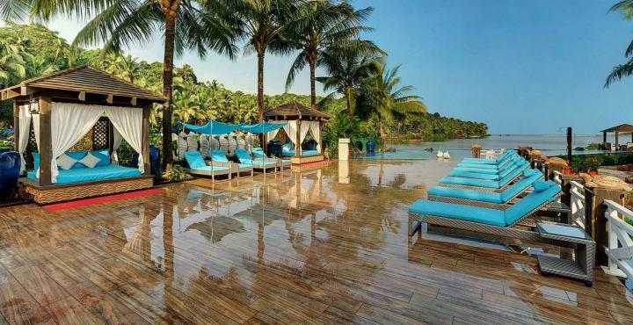

**RESORT RIO**

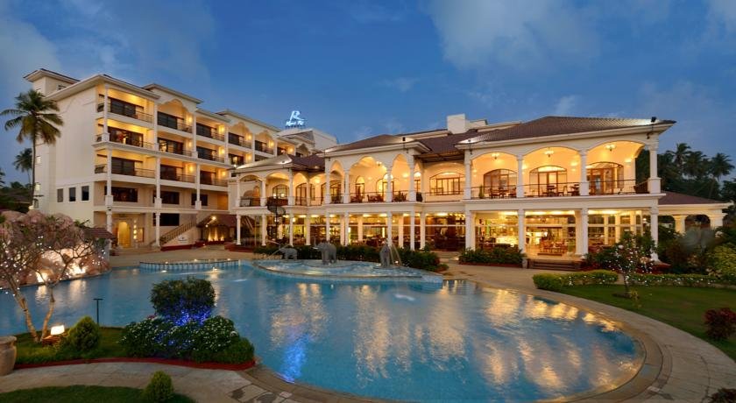

Resort Rio a Five star Luxury Deluxe Spa Resort in Goa is nestled on the banks of the Baga River. Is best known for its Architecture and hospitality The Resort is spread over 15 acres of serene riverside paradise and serves as an ideal location for leisure, relaxation , Corporate events and weddings alike.

**The Leela Goa**

The Leela Goa is one of those breath taking 5 star resorts that leave you in awe .The hotel is set in 75 lush acres with a pristine beach, a 12 hole golf course and world class dining making it the finest 5 star hotels in Goa.

**Wildernest**

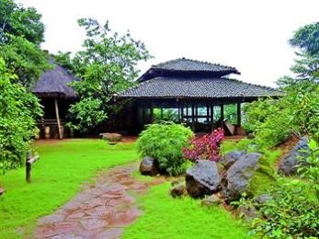

Nestled in the Swapnagandha valley, amidst thick expanse of forest tracts at 800mtrs above sea level, overlooking the Vazra falls and the entire panoramic view of Goa, Wildernest is an unsung wonder created to introduce you to your roots of nature and culture.

**Taj Exotica**

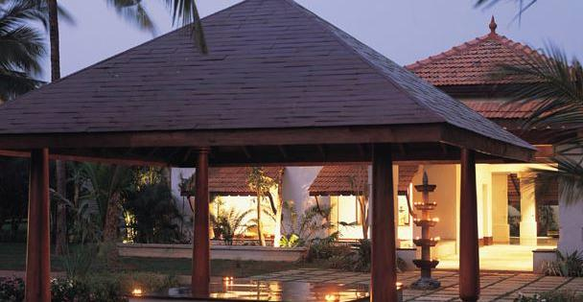

Taj Exotica is located in the southwest coast of Benaulim, overlooking the Arabian Sea this Mediterranean style resort has a way of slowing down time with its tranquil environment. The resort is a showcase of tropical inspired design touches, grand architecture, flower lined patios which reminds one of time before, making sure you have a wonderful and memorable stay.

[**The LaLiT Golf & Spa Resort Goa**](http://hotelz.makemytrip.com/makemytrip/site/hotels/detail?_track_param=1436267988879&city=GOI&country=IN&checkin=07092015&checkout=07112015&searchText=Goa,%20India&region=&area=&roomStayQualifier=1e0e&hotelId=200702151823314734&p=1&i=3)

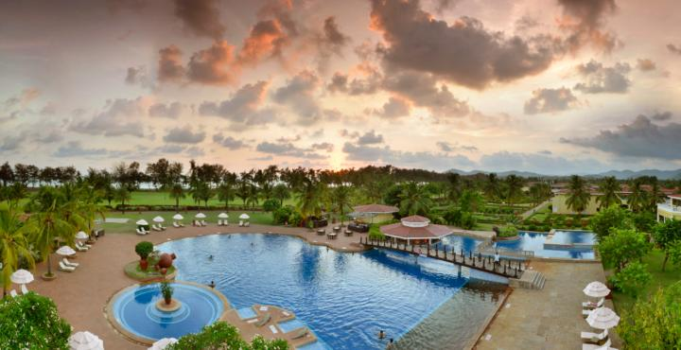

The Lalit Golf and Spa Resort Goa is an all-suite five starred resort spread over an enormous area of 85 acres. The resorts offers a breathtaking view of the Arabian sea with its exclusive kilometer long beachfront and ultra-luxurious architecture amidst an international standard 9 hole golf course , it truly makes it one of the most exquisite beach resorts in Goa.

**Sun Sand & Suits.**

Goa is synonymous with its scenic beaches. With a long stretch of coconut trees on one side of the clear white sands and calm waves on the other, the serene tranquility of our innumerable beaches makes for the perfect spot for a corporate event .

**Beach Resorts**



**CIDADE DE GOA**

Cidade De Goa is an ultra-luxurious resort spread across an area of 40 acres of lush green landscape. The resort has been gifted with a breath taking view of baingunim beach and is an ideal 5 star property for corporate events. The resort is one of the most iconic In Goa with its distinct Portuguese and Iberian architecture.

**Baywatch Resort**

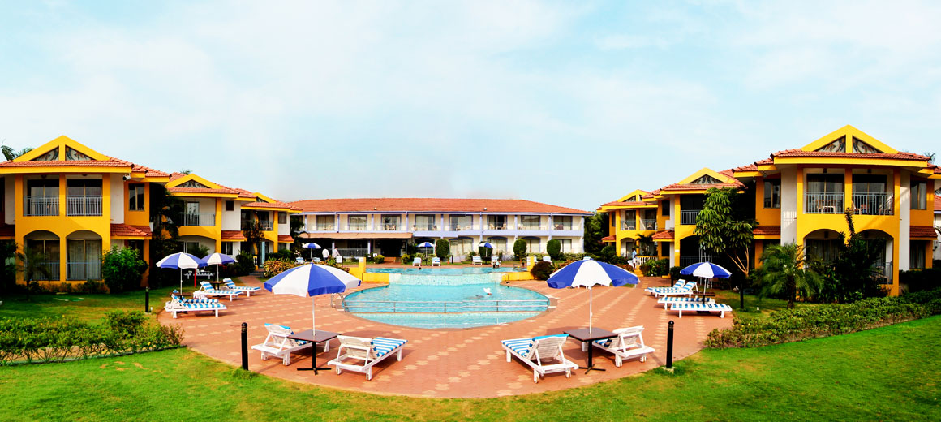

Baywatch Resort is nestled in the serene coastline of Sernabatim Beach in colva , this contemporary and luxurious resorts offers elegant and spacious rooms and Suits equipped with amenities to make you have a memorable holiday in Goa.

**Ramada Caravela Beach Resort**

Located on the serene sands of Varca Beach, Ramada Caravela Beach Resort is a 5-star property, spread over 24 acres and has 199 rooms. Each of the guest rooms, suites and villas has a private balcony that overlooks either the ocean or landscaped gardens or one of Goa's largest pool. A 9 hole golf course, a Casino and an Ayurveda Centre, differentiates this from any other five star in Goa.

**Zuri White Sands**



The Zuri White Sands in Goa sits on a picturesque white-sand beach, Varca. The resort boasts of a spectacular view of the sea from their Goan styled luxury rooms. The restaurant offers authentic Goan, European and Pan Asian cuisine that is sure to tickle your taste buds and a state of the art casino in its premises.

**Holiday Inn Resort**



Holiday Inn Resort is located at Mobor beach, Cavelossim, Goa. This five star beach resort has a huge property with a captivating style that combines traditional Goan architecture with contemporary design and luxurious finishing. You can choose spacious accommodation in a stunning beachfront setting with the option of a garden view, pool view or sea view.

Hinterland

Eco Resorts

Want to be one with nature while on vacation? , away from the hustle and bustle of city life and just unwind in a destination that’s peaceful and tranquil? Well Goa has few of the best Eco Resorts with the best of amenities.

**Stone water eco resort**

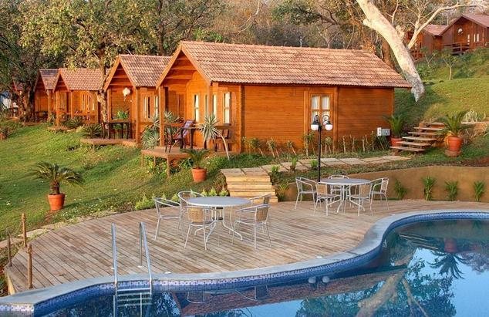

Stone water eco resort is an ideal location for conferences & training sessions. We offer our clients all the required facilities and infrastructure during their corporate offsite in Goa. The conference room at Stone Water can accommodate guests up to 150pax and they provide with buffet meals serving Authentic Goan, Indian, Fusion food with live barbecue stations.

**Pirache Village Eco Resort Goa** 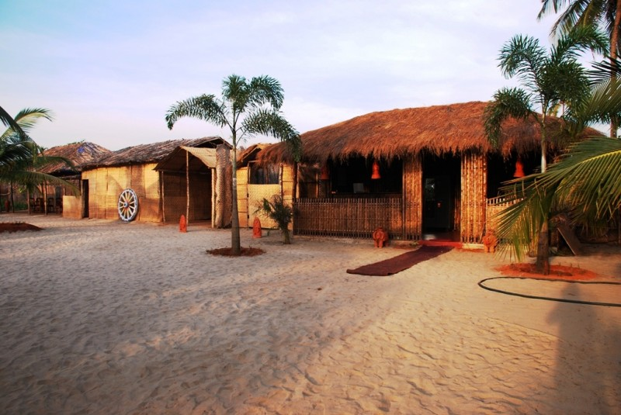

Pirache Village Eco Resort Goa is an authentic incarnation of an antique Indian Village. Situated on the serene Turtle Beach of Morjim, The soft silver sands, the fluffy crests of waves lapping the shores, the relaxing whispers of palm leaves, offering a breathtaking view of Chapora fort, all form the natural surroundings of this one of its kind Nature Resort in Goa.

**Wildernest**



Nestled in the Swapnagandha valley, amidst thick expanse of forest tracts at 800mtrs above sea level, overlooking the Vazra falls and the entire panoramic view of Goa, Wildernest is an unsung wonder created to introduce you to your roots of nature and culture.

**Ananda Resort**

Ananda resort is set down a steep hill in vagator amid mangroves of coconut and bamboo trees. The hotel is famous for its peace calm and quiet, the Full moon café is home to parties in the season and a library in the upper deck just adds to the whole charm of this nature resort.

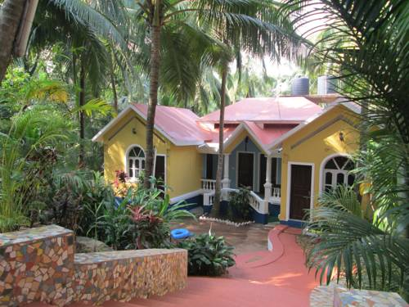

**Laguna Anjuna**

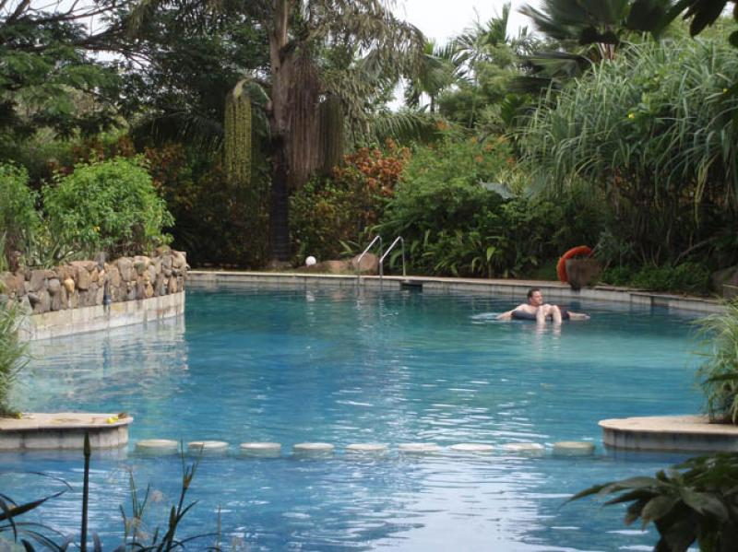

Laguna anjuna offers 2 bedroom cottages with living room and attached bathrooms which is ideal for families and friends travelling to revel in the quiet, restful serene atmosphere that Laguna anjuna exudes. Another distinct feature of the hotel is its large tropical garden and swimming pool. Best for people who love their sense of space, adventure and tranquility.

**Heritage**

**Heritage Hotels**

**Panjim Inn**

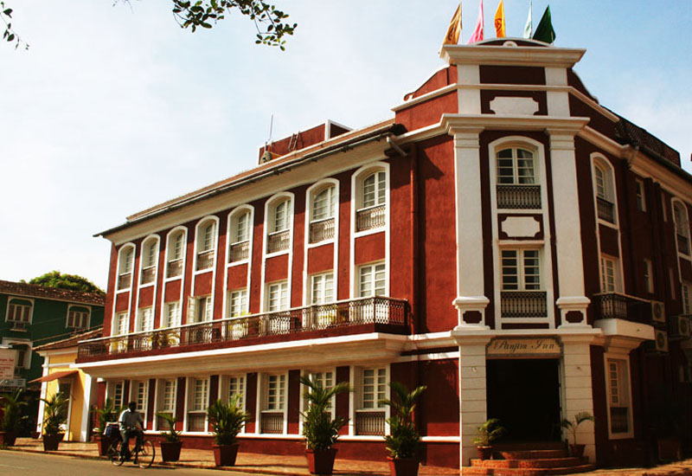

This Heritage Hotel has 24 spacious rooms, each individual in character. Modern facilities include wi-fi, air-conditioning, ensuite bathrooms which juxtapose with period furniture, Four-Poster beds and carved Rosewood almirahs. Embellishments include Collectibles and Antiques together with fine Art from an in house Art Gallery making for an air of Romance and Color.

**Panjim Peoples**

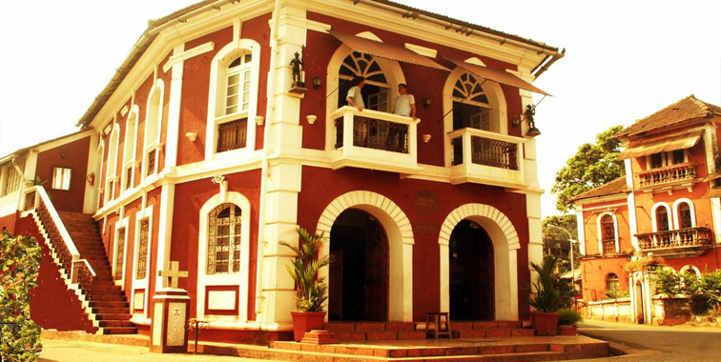

An elegant and eye catching vintage mansion built in the early 1800s, Welcome Heritage Panjim Peoples is a sprawling building which has brought back some of its original grandeur and helped recapture the nostalgia, poignance and aura of the romantic Past. On the first floor there are 4 exclusive and spacious heritage rooms about 30-40 square meters in size. The rooms are furnished with top quality antique furniture: Four Poster double/single beds in Rosewood, Almirahs, Divans, dressing tables, gilded pelmets, original art, planter’s chairs & lace curtains.

**Panjim Pousada**

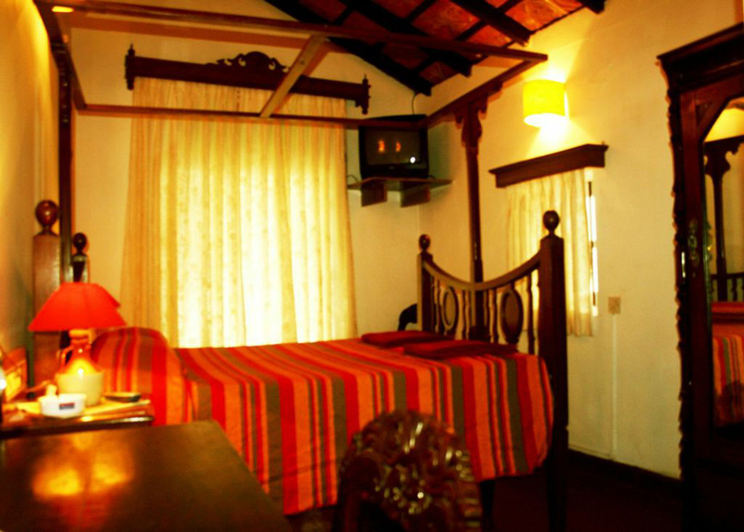

Panjim Pousada is a relative oasis of tranquility amongst the hustle-bustle of busy streets. It has the distinction of being one of the few Hindu houses in a predominantly Catholic precinct in Asia’s only Latin Quarter of Fontainhas. The Hotel has 9 highly individual rooms. The flooring is a harmonious blend of mosaic and the decor, a mix of the old world and antique.

**Casa Palacio Siolim House**

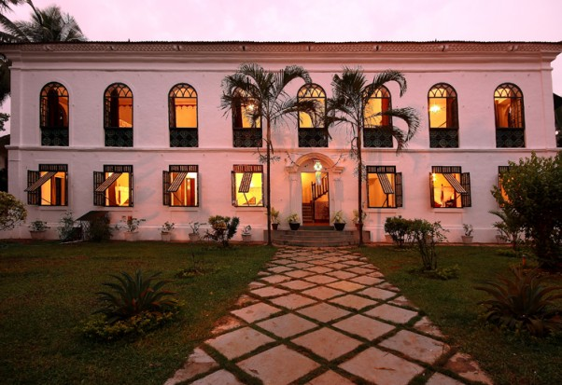

Casa Palacio Siolim House is a 350 year old Heritage Hotel in Goa, built in 1675. It is a Palacio that dates from the earliest times of the Portuguese occupation of Goa, beautifully restored as a home which, now doubles as a private seven room heritage boutique hotel in Goa.

**The Heritage**

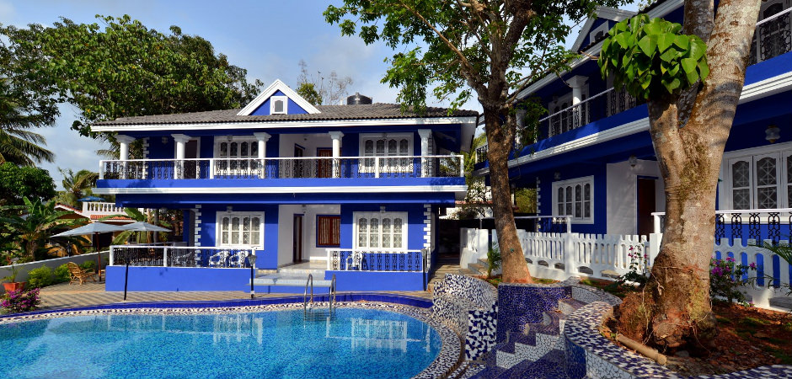

The Heritage is a quaint, century - old well restored heritage boutique resort with the aura of the old world charm that takes one down memory lane. It serves as a testament to the magnificent architecture and traditional opulence of the Portuguese colonization of Goa.

**Vivenda dos Palhacos**

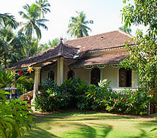

Vivenda dos Palhacos is a one hundred year old, carefully renovated house set on a very quiet village of Majorda, in South Goa. The longest beach, with the most beautiful sand in Goa, is about a kilometer away. At the front of the house, is a modest Portuguese Mansion, built in 1929. It has a hall, two large bedrooms with ensuite bathrooms, a sitting room leading out to a veranda and a large dining room to seat twenty.

**Arco Iris Homestay**

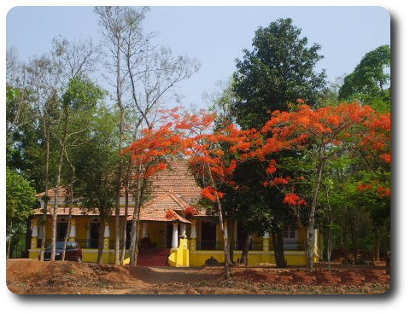

Arco Iris is a 100 year old elegantly restored colonial house built on a sprawling 1.5 acre property is elegant and tranquil. The fully equipped modern kitchens, well furnished rooms and friendly support staff adds to the grandeur of the house.